H3 PLUS Firmware Upgrade Process
- Install the CH340 driver (found in the folder as CH341SER.zip). If it's already installed, you can skip this step.
- Power on the H3 PLUS while holding the PTT and Key 1. The screen should remain black, and the green LED at the top should stay on steadily.
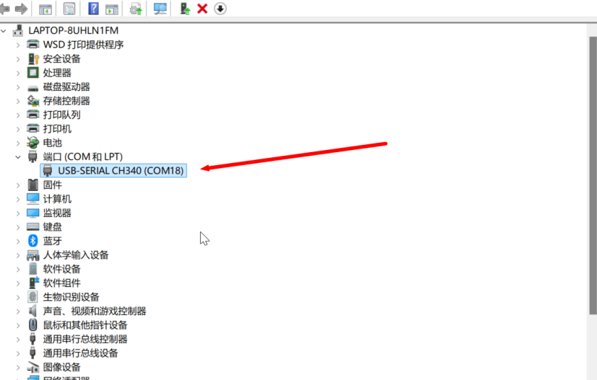
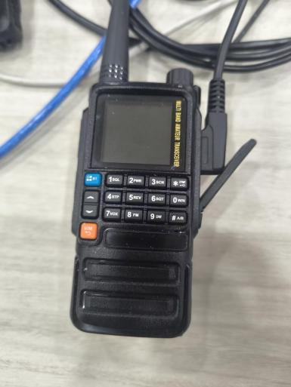

- Connect the radio to the computer using the programming cable, then check the Device Manager to see if a COM port appears (as shown in the image above).
- Open the PC software updata.exe.
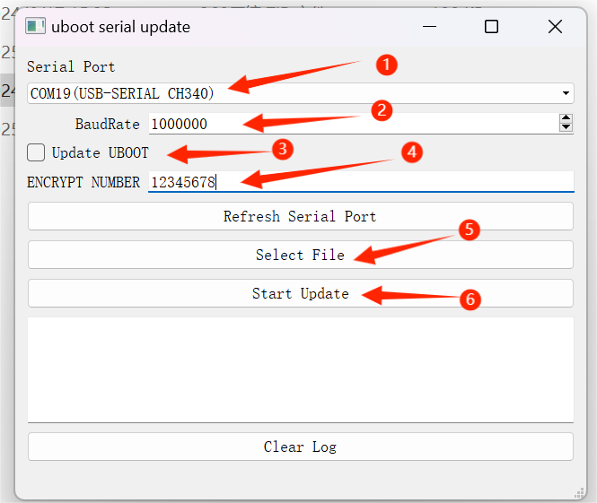
- Select the COM port that connects your computer to the H3 PLUS.
- Set the baud rate to 1000000.
- Do not check the “UPDATE UBOOT” option.
- Enter 12345678
- Select the xxx.bin firmware file.
- Start the upgrade. Once the log shows a success message, you can restart the radio.

